mvn clean package -Dmaven.test.skip=true

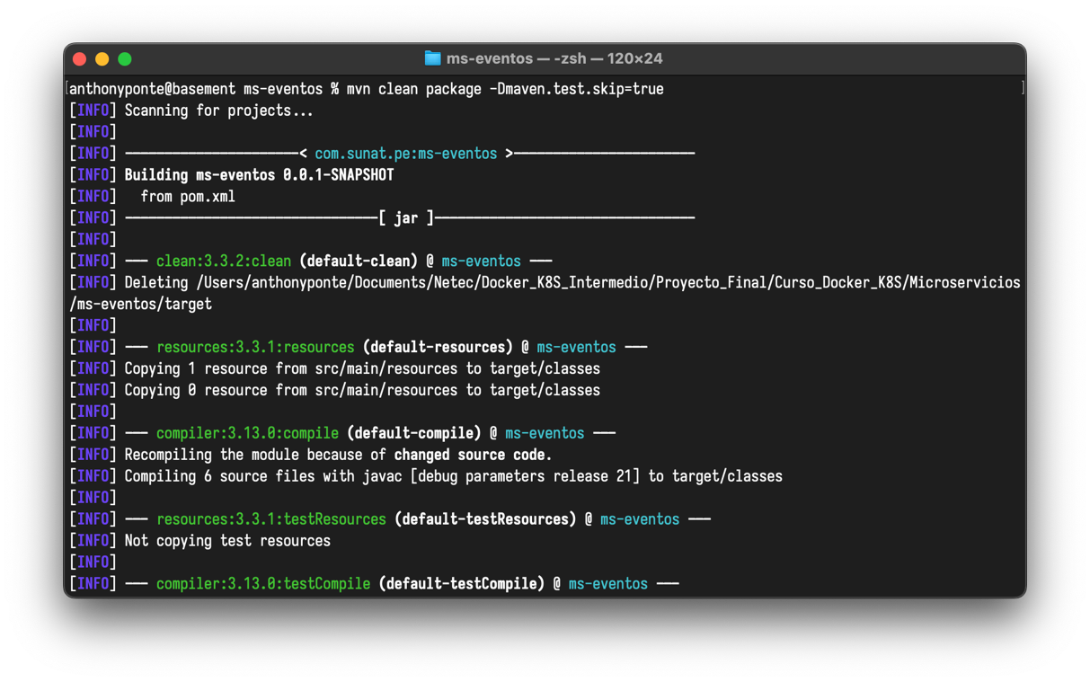

docker build -t ms-eventos:v1 .

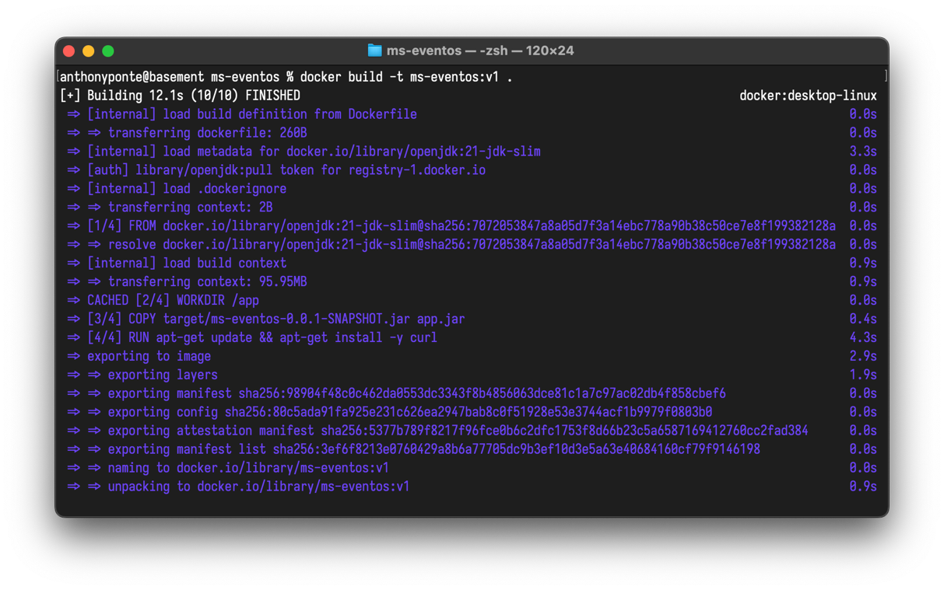

docker tag ms-eventos:v1 anthonyponte/ms-eventos:v1

docker push anthonyponte/ms-eventos:v1

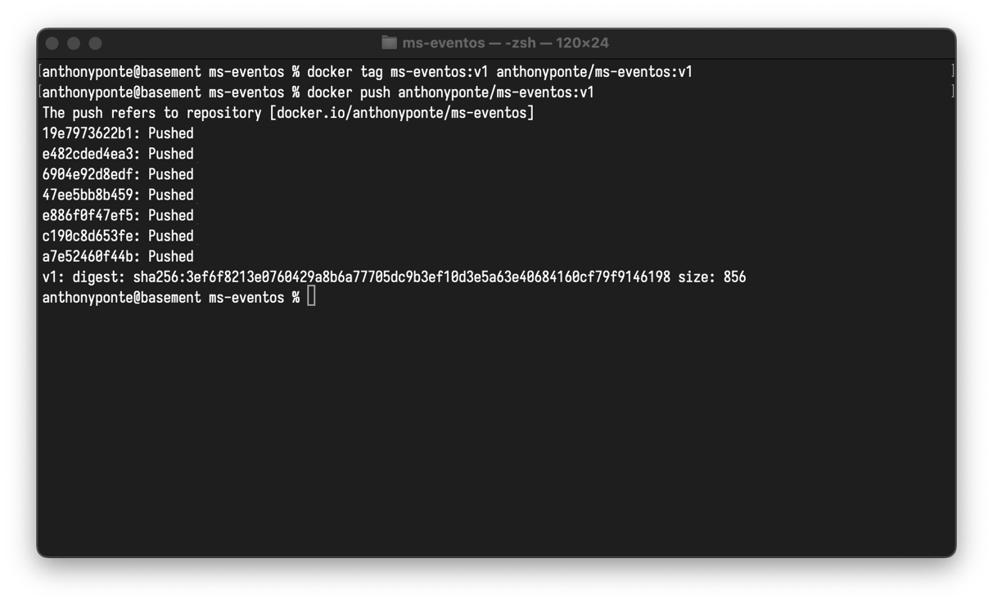

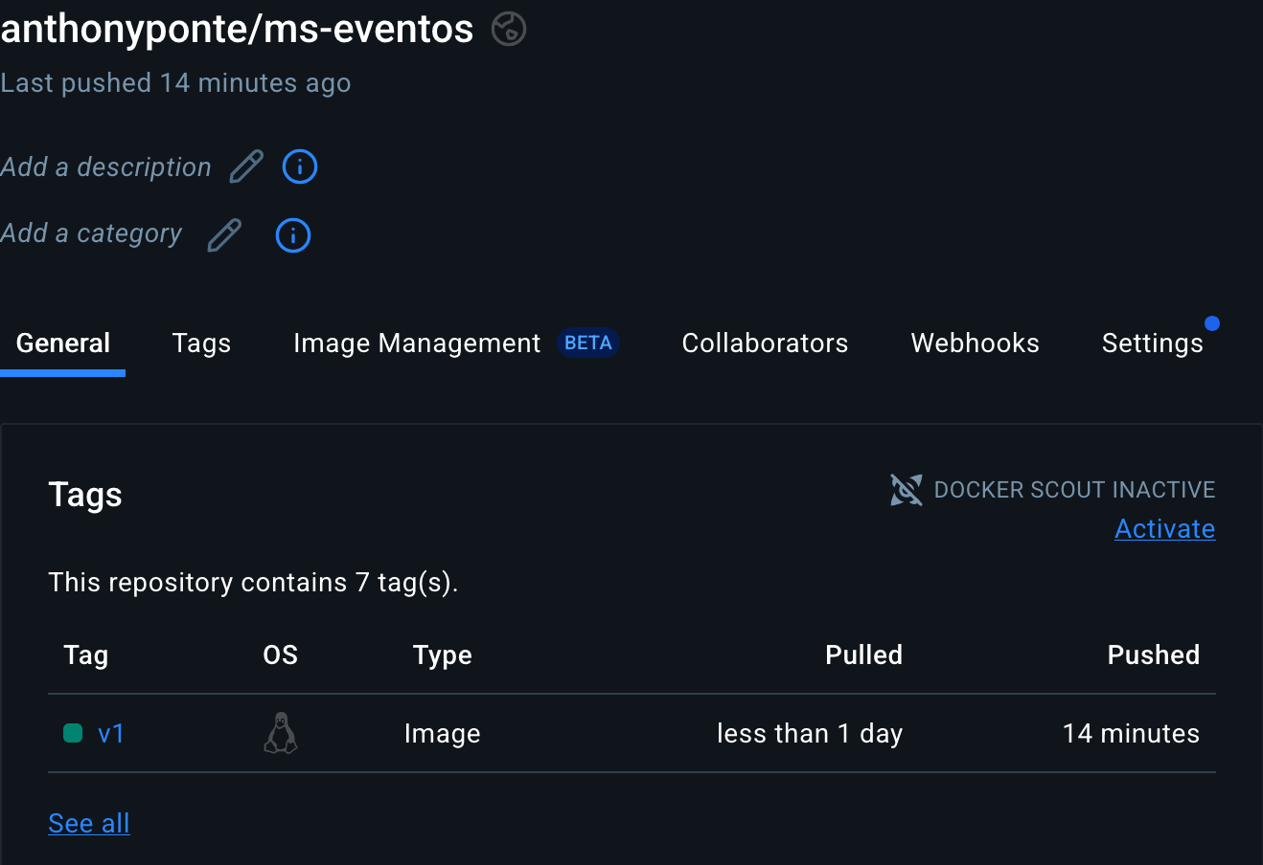

kubectl apply -f cluster-role.yml

kubectl get clusterroles | grep grupo2

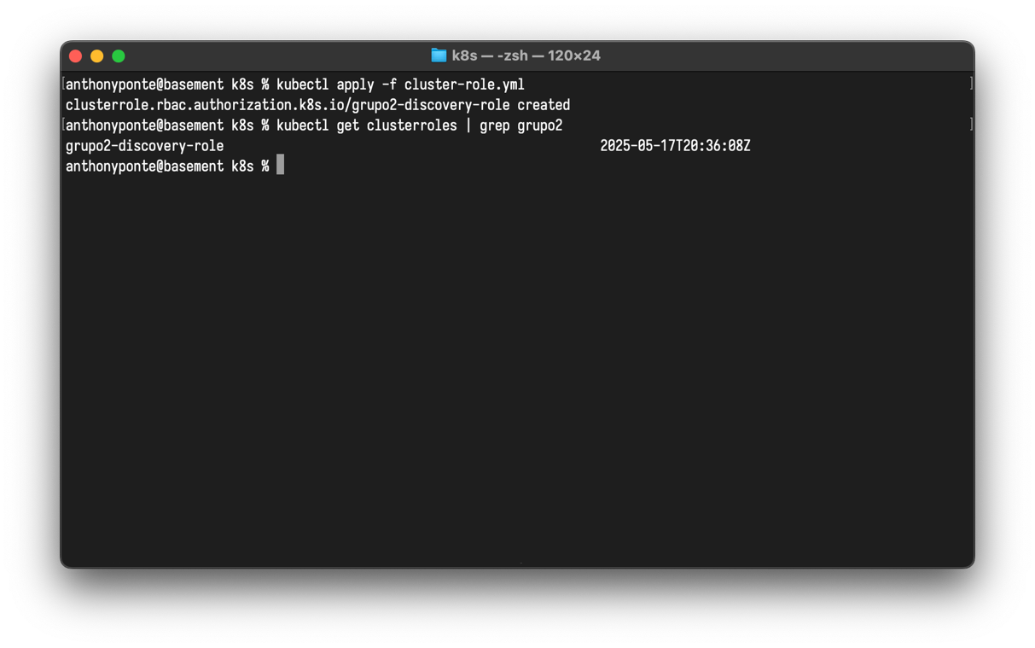

kubectl apply -f cluster-role-binding.yml

kubectl get clusterrolebindings | grep grupo2

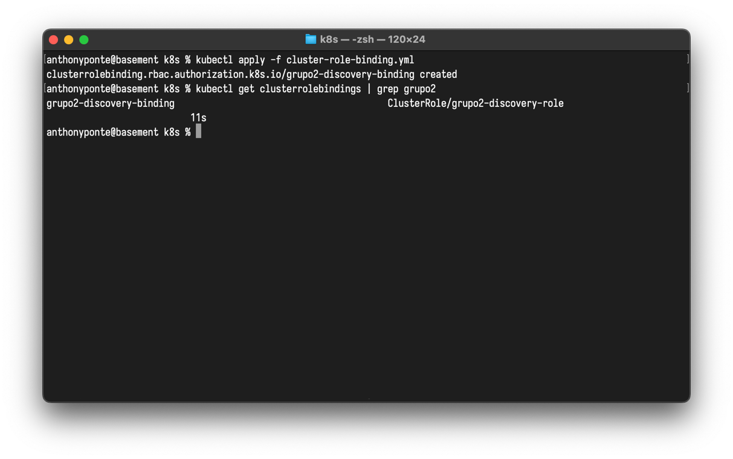

kubectl apply -f secret.yml

kubectl get secrets

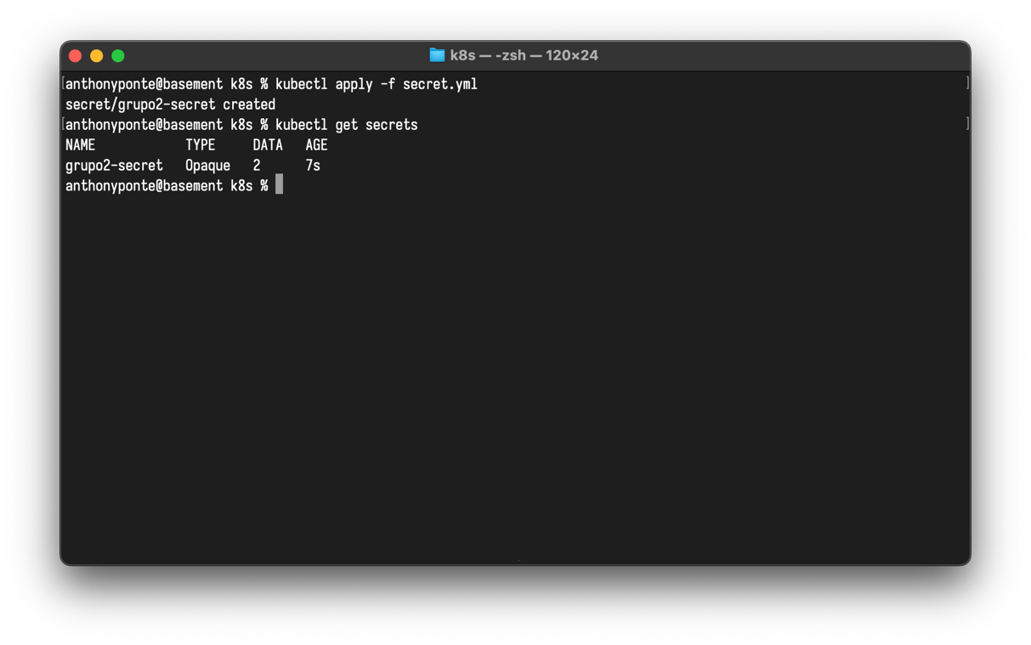

kubectl apply -f ms-eventos-configmap.yml

kubectl apply -f ms-eventos-deployment.yml

kubectl apply -f ms-eventos-service.yml

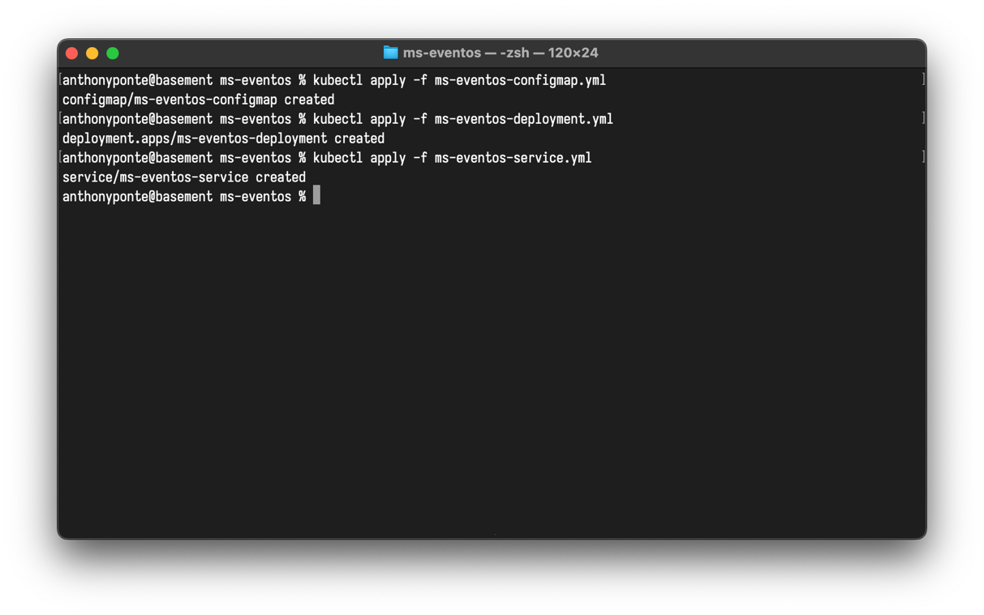

kubectl get configmaps | grep ms

kubectl get deployments | grep ms

kubectl get service | grep ms

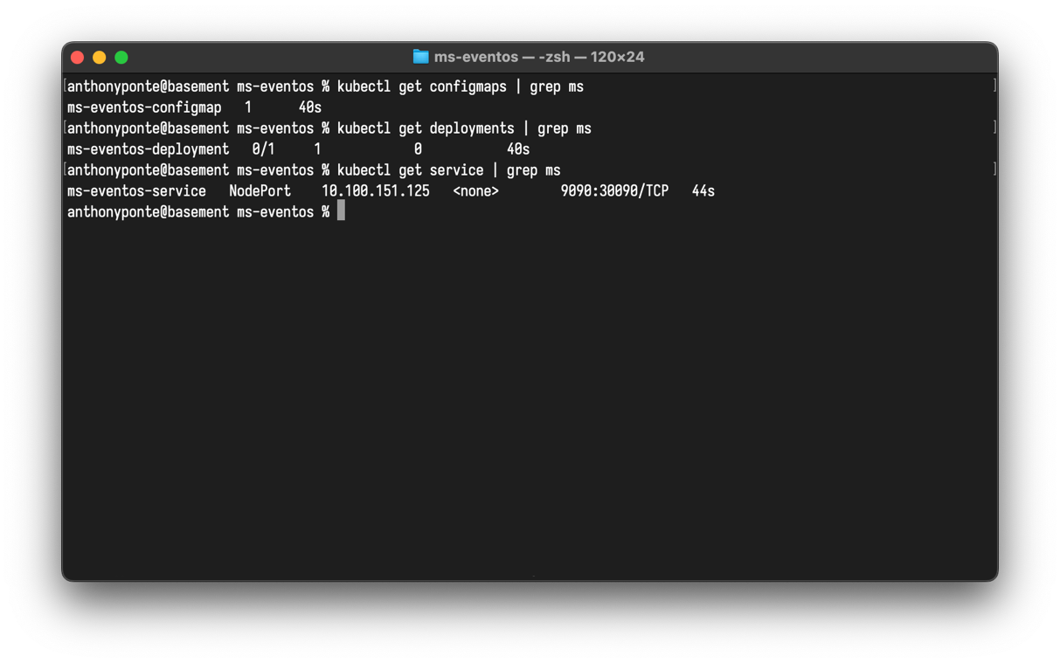

kubectl get pods | grep ms

